- Given two jugs with capacities X liters and Y liters, and an infinite water supply, develop a program to determine the steps required to obtain Z liters of water in either of the jugs using BFS and DFS.

Program:
Using BFS:
from collections import deque

def is_goal(state, Z):
return Z in state

def get_next_states(state, X, Y):
a, b = state
return [
(X, b), # Fill Jug X
(a, Y), # Fill Jug Y
(0, b), # Empty Jug X
(a, 0), # Empty Jug Y
(max(a - (Y - b), 0), min(Y, b + a)), # Pour X -> Y
(min(X, a + b), max(b - (X - a), 0)), # Pour Y -> X
]

def bfs(X, Y, Z):
queue = deque()
visited = set()
parent = {}

queue.append((0, 0))
visited.add((0, 0))
parent[(0, 0)] = None

while queue:
current = queue.popleft()
if is_goal(current, Z):
path = []
while current is not None:
path.append(current)
current = parent[current]
path.reverse()
return path

for state in get_next_states(current, X, Y):
if state not in visited:
visited.add(state)
queue.append(state)
parent[state] = current
return None

# Main function with runtime input
if __name__ == "__main__":
X = int(input("Enter capacity of Jug X: "))
Y = int(input("Enter capacity of Jug Y: "))
Z = int(input("Enter the target volume Z: "))

# Check if solution is possible (GCD must divide Z)
from math import gcd
if Z > max(X, Y):
print("Target volume cannot be more than the capacity of both jugs.")
elif Z % gcd(X, Y) != 0:
print("No solution possible because Z is not a multiple of GCD(X, Y).")
else:
result = bfs(X, Y, Z)
if result:
print("\nSteps to get", Z, "liters:")
for step in result:
print(step)
else:
print("No solution found.")

Output:
Enter capacity of Jug X: 5
Enter capacity of Jug Y: 3
Enter the target volume Z: 4

Steps to get 4 liters:
(0, 0)
(5, 0)
(2, 3)
(2, 0)
(0, 2)
(5, 2)
(4, 3)

Using DFS:
def is_goal(state, Z):
return Z in state

def get_next_states(state, X, Y):
a, b = state
return [
(X, b), # Fill Jug X
(a, Y), # Fill Jug Y
(0, b), # Empty Jug X
(a, 0), # Empty Jug Y
(max(a - (Y - b), 0), min(Y, b + a)), # Pour X -> Y
(min(X, a + b), max(b - (X - a), 0)), # Pour Y -> X
]

def dfs(X, Y, Z):
stack = []
visited = set()
parent = {}

stack.append((0, 0))
visited.add((0, 0))
parent[(0, 0)] = None

while stack:
current = stack.pop()
if is_goal(current, Z):
path = []
while current is not None:
path.append(current)
current = parent[current]
path.reverse()
return path

for state in get_next_states(current, X, Y):
if state not in visited:
visited.add(state)
stack.append(state)
parent[state] = current
return None

# Main function with runtime input
if __name__ == "__main__":
X = int(input("Enter capacity of Jug X: "))
Y = int(input("Enter capacity of Jug Y: "))
Z = int(input("Enter the target volume Z: "))

from math import gcd
if Z > max(X, Y):
print("Target volume cannot be more than the capacity of both jugs.")
elif Z % gcd(X, Y) != 0:
print("No solution possible because Z is not a multiple of GCD(X, Y).")
else:
result = dfs(X, Y, Z)
if result:
print("\nSteps to get", Z, "liters:")
for step in result:
print(step)
else:
print("No solution found.")
Output:
Enter capacity of Jug X: 10
Enter capacity of Jug Y: 6
Enter the target volume Z: 8

Steps to get 8 liters:
(0, 0)
(0, 6)
(6, 0)
(6, 6)
(10, 2)
(0, 2)
(2, 0)
(2, 6)
(8, 0)

- Develop a Chabot that responds to user inputs based on predefined rules. The Chabot should be able to handle basic queries such as greetings, asking for help, and providing predefined responses based on keywords
Program:
import datetime
import random
import string

# Define keyword-response mapping (intent rules)
rules = {
"greetings": {
"keywords": ["hello", "hi", "hey", "good morning", "good evening"],
"responses": ["Hello!", "Hi there!", "Hey!", "Greetings!", "Howdy!"]
},
"help": {
"keywords": ["help", "assist", "support", "problem"],
"responses": [
"I'm here to help. What do you need assistance with?",
"How can I assist you today?",
"Sure, tell me your issue.",
]
},
"thanks": {
"keywords": ["thank", "thanks", "thank you", "appreciate"],
"responses": ["You're welcome!", "No problem!", "Anytime!", "Glad I could help!"]
},
"name": {
"keywords": ["your name", "who are you"],
"responses": ["I'm ChatBot, your virtual assistant!", "You can call me ChatBot."]
},
"time": {
"keywords": ["time", "current time", "what time"],
"responses": [f"The current time is {datetime.datetime.now().strftime('%H:%M:%S')}"]
},
"date": {
"keywords": ["date", "today's date", "what date"],
"responses": [f"Today's date is {datetime.date.today().strftime('%Y-%m-%d')}"]
},
"weather": {
"keywords": ["weather", "forecast", "rain", "temperature"],
"responses": [
"I can't fetch live weather, but I suggest checking a weather app!",
"Please check weather.com or AccuWeather for updates."
]
}
}

# Fallback/default responses
default_responses = [
"I'm not sure how to respond to that.",
"Can you please rephrase?",
"Hmm, I don't understand. Try asking something else.",
"Interesting... Can you explain more?"
]

# Function to clean and tokenize user input
def clean_input(user_input):
return user_input.lower().translate(str.maketrans('', '', string.punctuation)).split()

# Match user input to intent category
def get_intent(user_input):
tokens = clean_input(user_input)
for intent, data in rules.items():
for word in tokens:
if word in data["keywords"] or any(kw in user_input.lower() for kw in data["keywords"]):
return intent
return None

# Get response based on intent
def get_response(intent):
if intent:
return random.choice(rules[intent]["responses"])
return random.choice(default_responses)

# Main chatbot loop
def chatbot():
print(" ChatBot: Hello! Ask me anything. Type 'exit' to quit.\n")
while True:
user_input = input("You: ")
if user_input.lower() == "exit":
print("ChatBot: Goodbye!")
break
intent = get_intent(user_input)
response = get_response(intent)
print("ChatBot:", response)

# Run the chatbot
if __name__ == "__main__":
chatbot()
Output:
ChatBot: Hello! Ask me anything. Type 'exit' to quit.

You: hi
ChatBot: Hey!
You: who are you
ChatBot: I'm ChatBot, your virtual assistant!
You: how are you
ChatBot: Interesting... Can you explain more?
You: todays date
ChatBot: Today's date is 2025-05-30
You: time
ChatBot: The current time is 15:06:30
You: will you help me
ChatBot: How can I assist you today?
You: exit
ChatBot: Goodbye!

- Develop a program to find the shortest path between a start node and a goal node in a weighted graph using the A algorithm*. The program should consider both the actual cost (g) and the heuristic estimate (h) to determine the best path
Program:
import heapq

def a_star(graph, start, goal, heuristics):
# Priority queue with elements as (f, g, node, path)
queue = [(heuristics[start], 0, start, [start])]
visited = set()

while queue:
f, g, current, path = heapq.heappop(queue)

if current == goal:
print("Shortest path:", " -> ".join(path))
print("Total cost:", g)
return

if current in visited:
continue
visited.add(current)

for neighbor, cost in graph[current].items():
if neighbor not in visited:
new_g = g + cost
new_f = new_g + heuristics[neighbor]
heapq.heappush(queue, (new_f, new_g, neighbor, path + [neighbor]))

print("No path found!")

# Sample weighted graph
graph = {
'A': {'B': 1, 'C': 4},
'B': {'D': 5, 'E': 12},
'C': {'F': 2},
'D': {'G': 3},
'E': {'G': 2},
'F': {'G': 3},
'G': {}
}

# Heuristic values for each node (example values)
heuristics = {
'A': 7,
'B': 6,
'C': 5,
'D': 3,
'E': 3,
'F': 1,
'G': 0
}

# Get input from user
start_node = input("Enter start node: ").upper()
goal_node = input("Enter goal node: ").upper()

# Run A* algorithm
a_star(graph, start_node, goal_node, heuristics)

Output:
Enter start node: a
Enter goal node: g
Shortest path: A -> B -> D -> G
Total cost: 9

- Develop a program that simulates Forward Chaining and Backward Chaining inference techniques for knowledge-based systems. The system should use predefined rules to infer conclusions from given facts.
Program:
# Sample knowledge base
rules = [
{"if": ["A"], "then": "B"},
{"if": ["B"], "then": "C"},
{"if": ["C"], "then": "D"},
{"if": ["A", "E"], "then": "F"},
{"if": ["F"], "then": "G"}
]

initial_facts = {"A", "E"}

# Forward Chaining implementation
def forward_chaining(rules, facts):
inferred = set()
changed = True

print("\nForward Chaining Trace:")
while changed:
changed = False
for rule in rules:
if rule["then"] not in facts and all(cond in facts for cond in rule["if"]):
facts.add(rule["then"])
inferred.add(rule["then"])
print(f"Inferred {rule['then']} using {rule['if']}")
changed = True
return inferred

# Backward Chaining implementation
def backward_chaining(rules, facts, goal, visited=None):
if visited is None:
visited = set()

if goal in facts:
return True
if goal in visited:
return False

visited.add(goal)
for rule in rules:
if rule["then"] == goal:
if all(backward_chaining(rules, facts, cond, visited) for cond in rule["if"]):
facts.add(goal) # Optional: cache inference
print(f"Derived {goal} using {rule['if']}")
return True
return False

# Main execution
if __name__ == "__main__":
print("Initial Facts:", initial_facts)

# Forward chaining
derived_facts = forward_chaining(rules, set(initial_facts))
print("All inferred facts:", initial_facts.union(derived_facts))

# Backward chaining
goal = input("\nEnter a goal to prove using Backward Chaining: ").strip().upper()
if backward_chaining(rules, set(initial_facts), goal):
print(f"Goal '{goal}' can be proven.")
else:
print(f"Goal '{goal}' cannot be proven.")
Output:
Initial Facts: {'A', 'E'}

Forward Chaining Trace:
Inferred B using ['A']
Inferred C using ['B']
Inferred D using ['C']
Inferred F using ['A', 'E']
Inferred G using ['F']
All inferred facts: {'G', 'D', 'F', 'C', 'E', 'B', 'A'}

Enter a goal to prove using Backward Chaining: c
Derived B using ['A']
Derived C using ['B']
Goal 'C' can be proven.

- Design a simple Expert System that takes a set of symptoms as input and suggests possible diseases based on predefined rules. The system should use IF-THEN rules to infer a diagnosis.
Program:
# Enhanced Expert System for Disease Diagnosis

disease_rules = {
"Flu": {"fever", "cough", "body ache", "fatigue"},
"Common Cold": {"cough", "sneezing", "sore throat", "runny nose"},
"COVID-19": {"fever", "cough", "loss of taste", "difficulty breathing", "fatigue"},
"Malaria": {"fever", "chills", "sweating", "headache"},
"Dengue": {"fever", "headache", "joint pain", "rash", "fatigue"},
"Chickenpox": {"fever", "rash", "itching", "fatigue"},
"Typhoid": {"fever", "headache", "abdominal pain", "diarrhea"},
}

def diagnose(symptoms):
scores = []
for disease, rule_symptoms in disease_rules.items():
matched = symptoms.intersection(rule_symptoms)
score = len(matched) / len(rule_symptoms)
if score > 0:
scores.append((disease, score, matched))
scores.sort(key=lambda x: x[1], reverse=True)
return scores

def main():
print("Welcome to the Expert System: Disease Diagnosis")
print("Enter symptoms separated by commas (e.g. fever, cough, headache). Type 'exit' to quit.")
while True:
user_input = input("\nEnter symptoms: ").strip().lower()
if user_input == 'exit':
print("Exiting the system. Take care!")
break
input_symptoms = {sym.strip() for sym in user_input.split(",") if sym.strip()}
if not input_symptoms:
print("Please enter at least one symptom.")
continue

results = diagnose(input_symptoms)
if not results:
print("No diseases matched your symptoms.")
else:
print("\nPossible diseases ranked by symptom match:")
for disease, score, matched in results:
percentage = score * 100
print(f"- {disease} ({percentage:.1f}% match). Symptoms matched: {', '.join(matched)}")

if __name__ == "__main__":
main()
Output:
Welcome to the Expert System: Disease Diagnosis
Enter symptoms separated by commas (e.g. fever, cough, headache). Type 'exit' to quit.

Enter symptoms: fever, cough

Possible diseases ranked by symptom match:
- Flu (50.0% match). Symptoms matched: fever, cough
- COVID-19 (40.0% match). Symptoms matched: fever, cough
- Common Cold (25.0% match). Symptoms matched: cough
- Malaria (25.0% match). Symptoms matched: fever
- Chickenpox (25.0% match). Symptoms matched: fever
- Typhoid (25.0% match). Symptoms matched: fever
- Dengue (20.0% match). Symptoms matched: fever

Enter symptoms:

- Compute central tendency measures and visualize data on plots- Pieplot, Boxplot, Histogram, Scatter plot and Density plot on CSV file

Dataset: Predict Students' Dropout and Academic Success
Program:
import pandas as pd
import matplotlib.pyplot as plt
import seaborn as sns

# Load the CSV
df = pd.read_csv('data.csv', delimiter=';')

# Compute Central Tendency
numeric_columns = [
"Admission grade",
"Age at enrollment",
"Curricular units 1st sem (grade)",
"Curricular units 2nd sem (grade)",
"Unemployment rate",
"Inflation rate",
"GDP"
]

mean_vals = df[numeric_columns].mean()
median_vals = df[numeric_columns].median()
mode_vals = df[numeric_columns].mode().iloc[0]

print("=== Mean ===\n", mean_vals)
print("\n=== Median ===\n", median_vals)
print("\n=== Mode ===\n", mode_vals)

# Set aesthetics
sns.set(style="whitegrid")
plt.figure(figsize=(16, 20))

# 1. Pie Chart – Target distribution
plt.subplot(3, 2, 1)
target_counts = df["Target"].value_counts()
plt.pie(target_counts, labels=target_counts.index, autopct='%1.1f%%', startangle=140, colors=sns.color_palette("pastel"))
plt.title("Target Distribution (Graduate vs Dropout)")

# 2. Boxplot – Semester Grades
plt.subplot(3, 2, 2)
sns.boxplot(data=df[["Curricular units 1st sem (grade)", "Curricular units 2nd sem (grade)"]])
plt.title("Boxplot of Semester Grades")

# 3. Histogram – Age at Enrollment
plt.subplot(3, 2, 3)
sns.histplot(df["Age at enrollment"], bins=20, kde=False, color="skyblue")
plt.title("Histogram of Age at Enrollment")

# 4. Scatter Plot – Admission Grade vs 1st Sem Grade
plt.subplot(3, 2, 4)
sns.scatterplot(x="Admission grade", y="Curricular units 1st sem (grade)", data=df, alpha=0.6)
plt.title("Admission Grade vs 1st Sem Grade")

# 5. Density Plot – 1st Semester Grades
plt.subplot(3, 2, 5)
sns.kdeplot(df["Curricular units 1st sem (grade)"], shade=True, color="purple")
plt.title("Density Plot of 1st Semester Grades")

plt.tight_layout()
plt.show()

Output:
=== Mean ===
Admission grade 126.978119
Age at enrollment 23.265145
Curricular units 1st sem (grade) 10.640822
Curricular units 2nd sem (grade) 10.230206
Unemployment rate 11.566139
Inflation rate 1.228029
GDP 0.001969
dtype: float64

=== Median ===
Admission grade 126.100000
Age at enrollment 20.000000
Curricular units 1st sem (grade) 12.285714
Curricular units 2nd sem (grade) 12.200000
Unemployment rate 11.100000
Inflation rate 1.400000
GDP 0.320000
dtype: float64

=== Mode ===
Admission grade 130.00
Age at enrollment 18.00
Curricular units 1st sem (grade) 0.00
Curricular units 2nd sem (grade) 0.00
Unemployment rate 7.60
Inflation rate 1.40
GDP 0.32
Name: 0, dtype: float64
<ipython-input-1-0ac3fb540488>:54: FutureWarning:

`shade` is now deprecated in favor of `fill`; setting `fill=True`.
This will become an error in seaborn v0.14.0; please update your code.

sns.kdeplot(df["Curricular units 1st sem (grade)"], shade=True, color="purple")

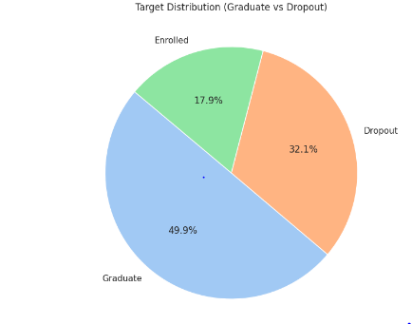
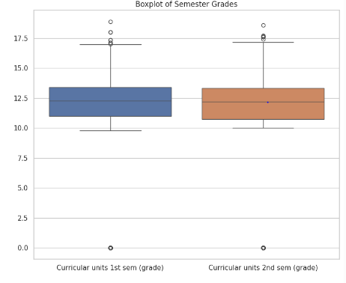
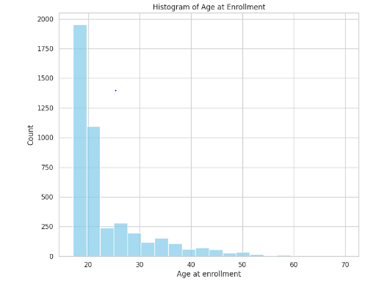
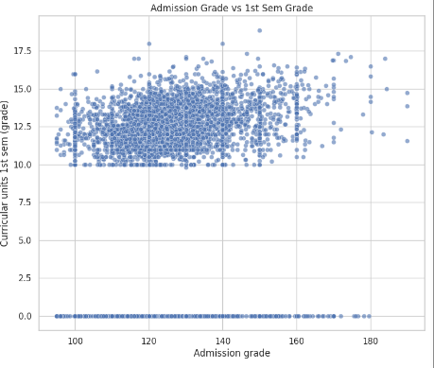
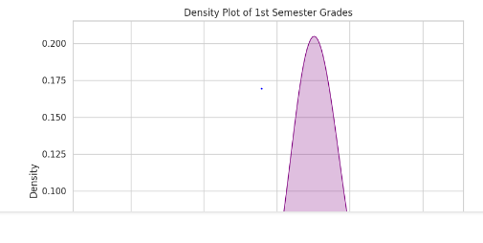

- To implement a Decision Tree algorithm for classification, visualize and evaluate its performance evaluation on a dataset.

Program:
import pandas as pd
from sklearn.model_selection import train_test_split
from sklearn.preprocessing import LabelEncoder
from sklearn.tree import DecisionTreeClassifier, plot_tree
from sklearn.metrics import accuracy_score, confusion_matrix, classification_report
import matplotlib.pyplot as plt
import seaborn as sns

# Load the dataset
df = pd.read_csv('data.csv', delimiter=';')

# Encode the target variable
label_encoder = LabelEncoder()
df['Target'] = label_encoder.fit_transform(df['Target'])

# Separate features and target
X = df.drop(columns=['Target'])
y = df['Target']

# Split the dataset
X_train, X_test, y_train, y_test = train_test_split(X, y, test_size=0.2, random_state=42)

# Train the Decision Tree model
clf = DecisionTreeClassifier(random_state=42)
clf.fit(X_train, y_train)

# Make predictions
y_pred = clf.predict(X_test)

# Evaluate the model
accuracy = accuracy_score(y_test, y_pred)
conf_matrix = confusion_matrix(y_test, y_pred)
class_report = classification_report(y_test, y_pred, target_names=label_encoder.classes_)

# Print evaluation results
print("Accuracy:", accuracy)
print("\nClassification Report:\n", class_report)

# Visualize the decision tree (top 3 levels for clarity)
plt.figure(figsize=(20, 10))
plot_tree(clf, feature_names=X.columns, class_names=label_encoder.classes_, filled=True, max_depth=3)
plt.title("Decision Tree Visualization (Top 3 Levels)")
plt.show()

# Plot the confusion matrix
plt.figure(figsize=(6, 5))
sns.heatmap(conf_matrix, annot=True, fmt="d", cmap="Blues",
xticklabels=label_encoder.classes_,
yticklabels=label_encoder.classes_)
plt.xlabel("Predicted")
plt.ylabel("Actual")
plt.title("Confusion Matrix")
plt.show()

Output:
Accuracy: 0.6768361581920904

Classification Report:
precision recall f1-score support

Dropout 0.73 0.64 0.68 316
Enrolled 0.36 0.41 0.38 151
Graduate 0.77 0.80 0.79 418

accuracy 0.68 885
macro avg 0.62 0.62 0.62 885
weighted avg 0.69 0.68 0.68 885

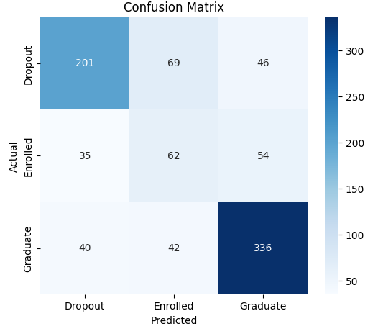
- Develop a Multiple Linear Regression to analyze the relationship between multiple independent and a dependent variable. Evaluate its performance using appropriate metrics.
Program:
import pandas as pd
from sklearn.model_selection import train_test_split
from sklearn.linear_model import LinearRegression
from sklearn.metrics import mean_squared_error, mean_absolute_error, r2_score

# Load the dataset
df = pd.read_csv('data.csv', delimiter=';')

# Select only numeric features for regression
numeric_df = df.select_dtypes(include=['int64', 'float64'])

# Define independent variables (X) and dependent variable (y)
# Replace 'Unemployment rate' with your actual target variable if different
X = numeric_df.drop(columns=['Unemployment rate'])
y = numeric_df['Unemployment rate']

# Train-test split
X_train, X_test, y_train, y_test = train_test_split(X, y, test_size=0.2, random_state=42)

# Create and train the model
model = LinearRegression()
model.fit(X_train, y_train)

# Predict on test data
y_pred = model.predict(X_test)

# Evaluate the model
mse = mean_squared_error(y_test, y_pred)
mae = mean_absolute_error(y_test, y_pred)
r2 = r2_score(y_test, y_pred)

# Print results
print("Mean Squared Error (MSE):", mse)
print("Mean Absolute Error (MAE):", mae)
print("R-squared Score (R²):", r2)

Output:
Mean Squared Error (MSE): 5.687924951920814
Mean Absolute Error (MAE): 1.9572468279564836
R-squared Score (R²): 0.18546183044303077

- To implement the Principal Component Analysis (PCA) algorithm for dimensionality reduction and visualize its effects on a dataset.
Program:
import pandas as pd
import numpy as np
import matplotlib.pyplot as plt
from sklearn.preprocessing import StandardScaler
from sklearn.decomposition import PCA

# Load dataset (change path if needed)
df = pd.read_csv("data.csv", delimiter=';')

# Separate features and target
X = df.drop(columns=["Target"])
y = df["Target"]

# Keep only numeric columns
X = X.select_dtypes(include=[np.number])

# Standardize the features
scaler = StandardScaler()
X_scaled = scaler.fit_transform(X)

# Apply PCA to reduce to 2 components
pca = PCA(n_components=2)
X_pca = pca.fit_transform(X_scaled)

# Explained variance
explained_variance = pca.explained_variance_ratio_
print("Explained Variance Ratio:", explained_variance)
print("Total Variance Explained:", np.sum(explained_variance))

# Plot PCA results
plt.figure(figsize=(10, 6))
for target in y.unique():
idx = y == target
plt.scatter(X_pca[idx, 0], X_pca[idx, 1], label=target, alpha=0.6)

plt.xlabel("Principal Component 1")
plt.ylabel("Principal Component 2")
plt.title("PCA Projection (2D) of Dataset")
plt.legend()
plt.grid(True)
plt.tight_layout()
plt.show()
Output:
Explained Variance Ratio: [0.17666395 0.0988699 ]
Total Variance Explained: 0.2755338434042034
